Sanitary waste management is a vital component of any water management efforts. Poorly managed sanitary waste can be a major pollutant source causing degradation of both surface and groundwater. When groundwater is a source of drinking water, as in the case if the Linn Sanitary District, that contamination is a threat to the health of its residents.

.

Whether addressed on-site or collected and treated at a centralized plant, the best sanitary wastewater management can be different for each watershed. Different soils, site conditions, civil subdivision, different political environment, and different codes all are involved in identifying the best sanitary waste management. There are advantages and disadvantages with handling sanitary wastewater on-site or by collecting it and treating it a central treatment plant.

Whatever type of treatment option is used, a comprehensive assessment of the planning area needs to be conducted. This includes looking at existing and future conditions, environmental impacts, regional plans, engineering possibilities, cost assessment, and resident’s preferences. The assessment of treatment options and variables of

is called a Facilities Plan. The Linn Sanitary District conducted its first Facility Planning Report in 2000 with amendments and updates in 2001, 2007 and 2010.

For a more comprehensive report, visit the Linn Sanitary District’s webpage, [*https://townoflinn.wi.gov/sanitary-district .*](https://townoflinn.wi.gov/sanitary-district%20.%20%20%20%20%20%20)

***Sanitary waste management***

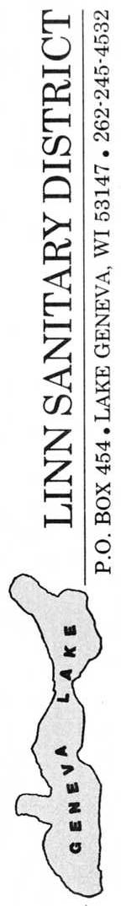

**LINN SANITARY DISTRICT**

P.O. Box 949

Lake Geneva, WI 53147

262-275-6300 ex.53

https://townoflinn.com/sanitary-district/

NEWSLETTER

FALL 2022

-Wastewater treatment Options, On-site vs. centralized-

-Linn Sanitary District’s Sanitary Wastewater Management, How We Got Here. Part 1

*-FOR OUR HEALTH-*

*-AND GENEVA LAKE’S PROTECTION-*

C:\Users\Ted\Documents\geneva lake\UW X figures\misc\WFP016.TIF 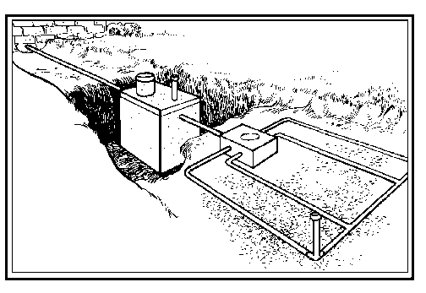

**GENEVA LAKE AND THE LINN SANITARY DISTRICT.**

Approximately 31 % of Geneva Lake’s watershed is served by public wastewater treatment plants. The remaining 69% of the watershed is served by private on-site wastewater treatment systems (POWTS). Of that, approximately 60% is in the Linn Sanitary District.

The incorporated municipalities of Fontana, Williams Bay and the City of Lake Geneva all collect their residents’ wastewater and pump it to wastewater treatment plants. Once there, the wastewater is treated and discharged out of the Geneva Lake watershed to ground or surface waters. Within the remainder of the watershed, excluding as few small area and individual residents that are serviced by neighboring municipalities, the rest of the watershed uses on site holding tanks or on-site treatment system.

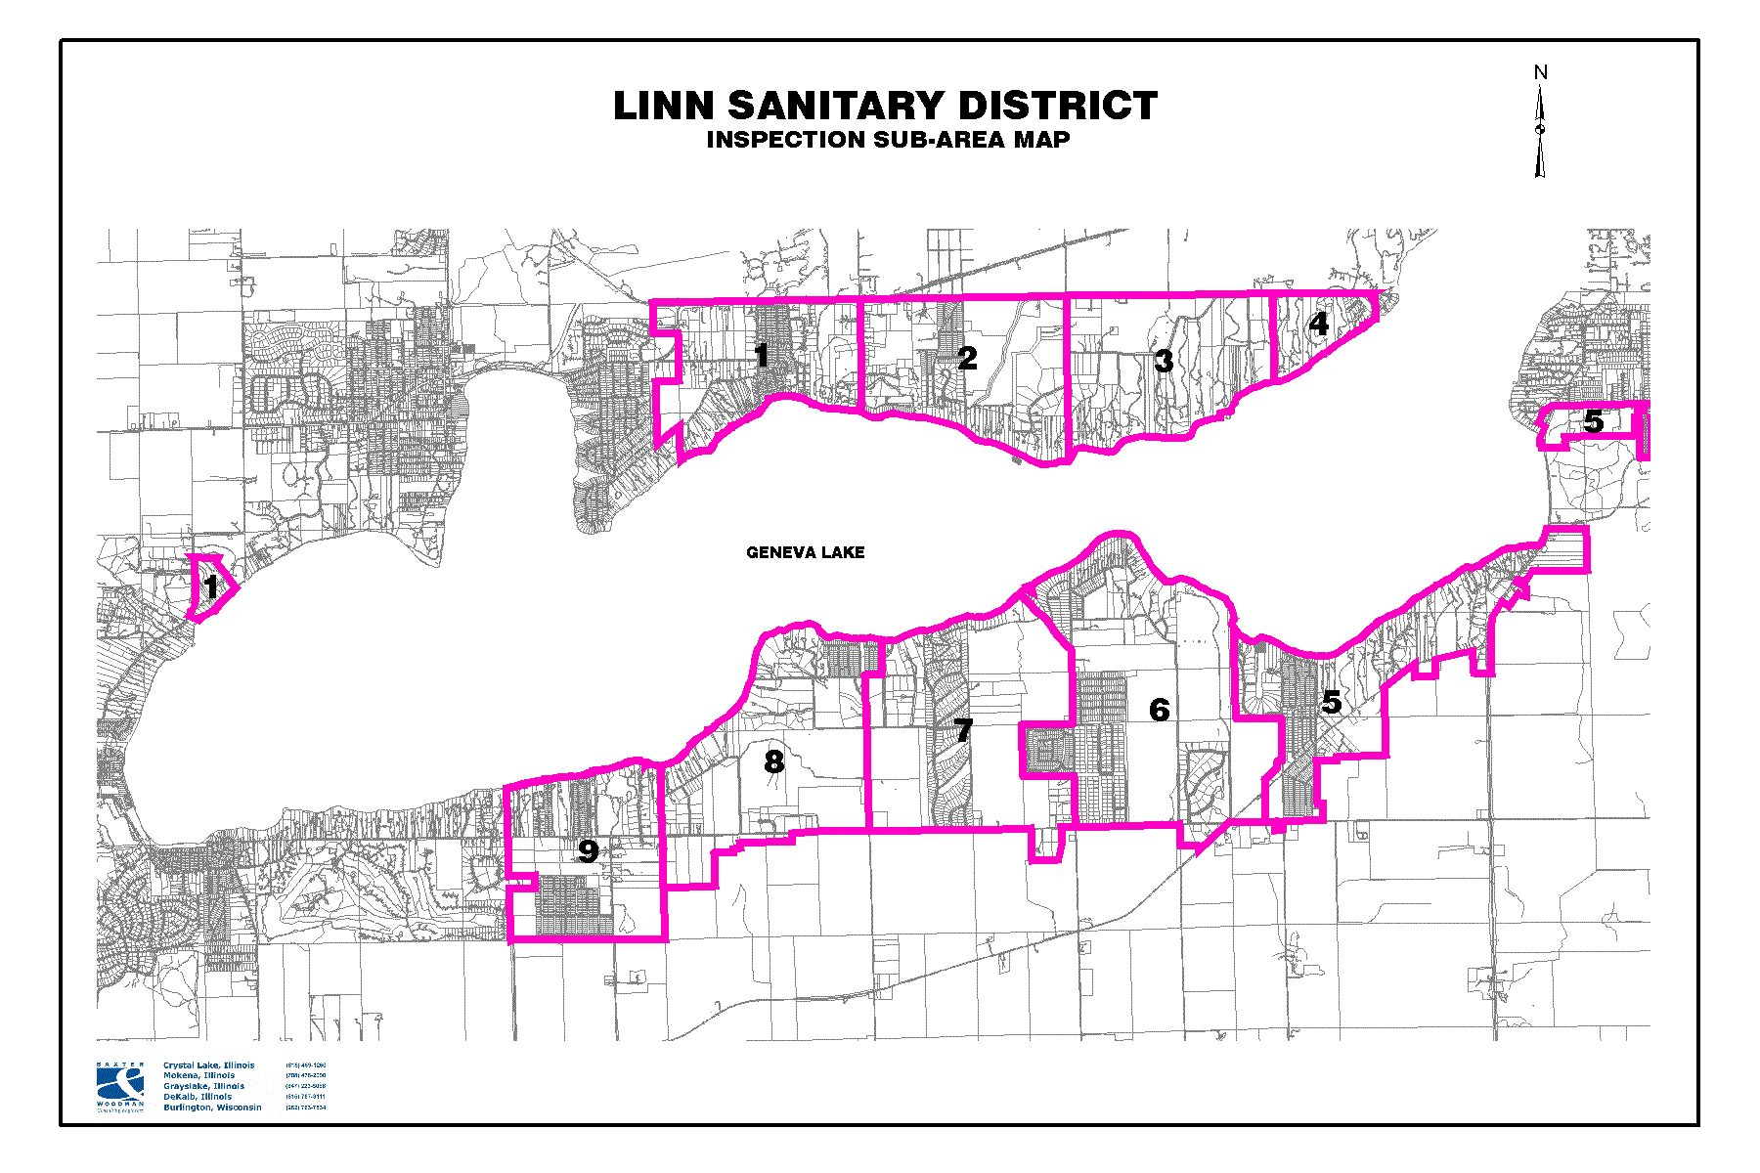

The above map shows the boundary of the Linn Sanitary District as defined by the red line. The numbered subsection designates sub-areas of the sanitary district used in our facilities planning and management implementation strategies.

**LINN SANITARY DISTRICT PLANNING PROCESS.**

**HOW WE GOT HERE (Part 1)**

In the late 1990’s the Linn Sanitary District hired Baxter & Woodman Inc. to conduct our first Facilities Plan.

The purpose of a facilities plan is to evaluate current sanitary waste management and to determine if it has sufficient ability to meet existing and future needs. If not, then options to do so are evaluated. This includes six major tasks

Assessment of current condition

The effectiveness of current conditions

Assessment of future needs

Development and assessment of alternatives

Select a plan

Financial considerations

The initial inventory work told us things were changing and we

needed to plan for those changes. Two types of improvement to sanitary wastewater management were closely studied.

***Type 1*** *– On individual house by house bases, POWTS or*

*holding tanks*

***Type II****- District-wide or neighborhood bases.*

***IIA -*** *Treatment at existing neighboring plants.*

***IIB –*** *Treatment at a new, small, decentralized plants*

***IIC –*** *Treatment t a new Regional Plant*

***IID –*** *Community Holding Tanks*

Each type has its advantages and disadvantages. Our planning goal was to find the best fit for the Linn Sanitary District and its residents.

Efforts to explore these options led to the ***Type 1*** options being the most likely. This was especially true when cost, environmental and political consideration were included

In their quarterly publication titled “Pipeline” the National Small Flows Clearing House lists some general advantages of POWTS (septic systems).

-Simple, effective yet engineered wastewater treatment

-Less disruptive to the environment to install and maintain

-Less expensive to operate

-Provides wastewater treatment in areas where it woold not be

available.

-Can recharge the groundwater at or near the site of withdrawal.

With the majority residents in the District being seasonal, the cost of constructing any of the ***Type II*** options will incur cost to the homeowners 12 month a year, whether they were being used or not (paying off high construction and maintenance costs). ***Type I*** options put those cost to the individual and would be relative to the amount of system use.

Walworth County zoning allows for higher density of housing in centralized sewered area vs on-site systems. We would experience more construction, construction site erosion, more impervious areas, more runoff, and more congestion. Digging for sewer lines and lift stations along the shoreline would be a serious threat to the lake and to many of the large   
trees along the shoreline. All of this would result in a significant change to what we now know as the Geneva Lake area.

In the next newsletter we will explore more of the reasons how and why the Linn Sanitary District chose the ***Type I*** option.