Having committed to the use of Private On-Site Wastewater Treatment Systems (POWTS) as a means of wastewater management, the Linn Sanitary District has the responsibility to assure its residents that these systems are properly treating wastewater and not contaminating the groundwater.

***summer POWTS INSPECTIONS BEGIN***

The District has conducted POWTS inspections and monitored ground quality and private wells to meet that responsibility. Initiated in 2001 the District has inspected and shared with the owners over 1,323 POWTS located within the District. Many of the owners of systems our inspections found to have problems took the initiative to upgrade and repair their failing systems without having to initiate any enforcement actions. The District appreciates their commitment to

protecting Geneva Lake and its environs.

In 2020 the Linn Sanitation District initiated a re-inspection program of systems that were identified in earlier inspections as having problems and had no record of upgrades or repairs. During 2020, thirty-four systems were re-inspected by a Wisconsin licensed inspector. In 2021 another four systems were also inspected. All systems inspected in the las two years still had conditions that needed to be repaired.

The Linn Sanitary District does not have the authority to condemn these systems. We have been working with Walworth County Sanitation Department for their assistance to get these failing systems upgraded. Copies of inspections and evaluations have been sent to the Walworth County Sanitation Department for their action.

The Linn Sanitary District has worked hard to upgrade old POWTS and protect groundwater. Most of the homes in the Linn Sanitary District are on a three-year maintenance and inspection program administered by the Walworth County Sanitation Department.

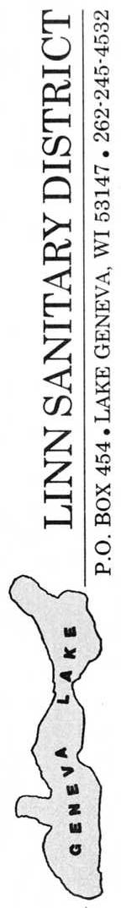

**LINN SANITARY DISTRICT**

P.O. Box 949

Lake Geneva, WI 53147

262-245-4532

https://townoflinn.com/sanitary-district/

NEWSLETTER

Spring 2022

-2020 and 2021 POWTS Inspections –

-Results of the five-year well testing for bacteria and nitrates-

*-FOR OUR HEALTH-*

*-AND GENEVA LAKE’S PROTECTION-*

C:\Users\Ted\Documents\geneva lake\UW X figures\misc\WFP016.TIF 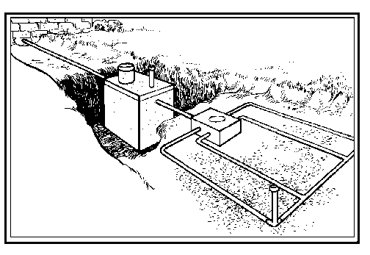

Over the last five years, in a cooperative effort by the Linn Sanitary District and the Geneva Lake Environmental Agency, selected private wells were annually tested for bacteria and nitrate-nitrogen (nitrate-n). Bacteria and nitrate-n are the two most common well contaminants. 2021 was the last year of the testing program.

Listed below is a summary of the 2021 private well test results.

* **Total private wells tested - 11**
* **Private wells that met total coliform and E-coli bacteria drinking water standards – 11 (100%).**
* **Private wells that met nitrate drinking water standard – 11 (100%).**
* **Number of well that had detectable nitrate level – 4 (36%).**

During the 2021 well testing program all private wells meet the Wisconsin Drinking Water Standards for both bacteria (absent) and nitrate-nitrogen (10 mg/l).

The results of well test on 18 public wells were also inventoried. All public water supplies are required to be tested by state law.

**2021 Well Testing Summary**

**s**

Their results can be viewed at <https://prodoasext.dnr.wi.gov/inter1/pws2$.startup>. These samples are often collected and tested by Walworth County Public Health or by the owners. Listed below are the results of a select few of the public wells found in the Geneva Lake area. All eighteen wells meet the Wisconsin Drinking Water Standards.



**2017 – 2021 Private Well Test Results.**

**Five Year Well Testing Summary**

**s**

* **Total private well tested results over five years – 63**
* **Private wells that met total coliform bacteria drinking water standards (negative) over five years - 58 (92%).**
* **Private wells that tested negative for fecal bacteria - 63 (100%).**
* **Private wells that met the nitrate-n standard for drinking water over five years. – 63 (100%).**
* **Number of private wells that had detectable nitrate-N levels over five years of testing – 18 (29%).**
* **One private well accounted for five of the 18 detectable nitrate-n levels recorded in the private wells over five years.**

All private well tests over five-years meet the drinking water standard for fecal bacteria and nitrate-N. Five private well tests over the five years tested positive for total coliform. Four of the five were from the same well. Of the 18 private well test that had detectable nitrogen-N levels, five were from the same well.

**2017 -2021 Public Well Test Results.**

To better understand the groundwater quality of the Geneva Lake area beyond the limited private well testing, 18 public well test’s results from five years were also reviewed. A summary of the result is listed below.

* **Total number of public well test results reviewed – 93.**
* **Public water supplies that met the total coliform and fecal coliform bacteria drinking water standard (negative) – 93 (100%).**
* **Public water supplies that met the nitrate-n drinking water standard over five year – 93 (100%).**
* **Number of public water supplies tested over five years that had detectable nitrate-n levels – 26 (28%).**
* **Detectable nitrate-n values in the public water supplies recorded over five years ranged from 8.35 mg/l to 0.013 mg/l.**
* **Overall, nitrate-n values appear to be higher in the western portion of the Geneva Lake groundwater shed recharge area.**

Based upon the findings of this five-year well testing program and review of five years of public well testing data, these 156 data point indicate the groundwater quality in these test area does not exceed the drinking water stands for the State of Wisconsin. However, additional testing may be needed to better understand the results and their distribution.