Sanitary waste management within the Linn Sanitary District is addressed by Private On-Site Wastewater treatment systems (POWTS). To evaluate the existing wastewater management in the District, a comprehensive Facilities Planning process was initiated in the early 2000’s.

*Sanitary waste management*

In the last edition of this newsletter, the facilities planning process was discussed and how the Linn Sanitary District went through that planning process. Six major tasks of the planning process were discussed. These tasks assure that the planning process was comprehensive in considering present and future needs and their costs with an ultimate commitment to a plan.

Two major alternatives were studied, Alternative **Type I**, decentralized private on-site systems, and Alternative **Type II,** centralized treatment. The centralized alternative included looking at using existing treatment plants, collecting wastewater, treating at several small-scale treatment facilities, collecting the wastewater, and conveying it to a new centralized treatment plant, or the collection of wastewater and conveying it to decentralized or community holding tanks.

The Linn Sanitary District committed to the **Type 1** option, which addresses sanitary waste management on a house-by-house basis, using existing Private On-Site Wastewater Treatment Systems, replacement systems, upgraded systems or holding tanks. With the **Type 1** option a commitment to implement and enforce a rigorous inspection, education and maintenance program for its residents needed to be made by the District. This newsletter will look at the factors and considerations that led to choosing the **Type 1** option.

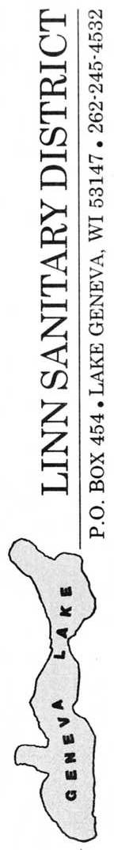

**LINN SANITARY DISTRICT**

P.O. Box 949

Lake Geneva, WI 53147

262-275-6300 ex.53

https://townoflinn.com/sanitary-district/

NEWSLETTER

April 2023

-Why **Type 1** sanitary waste management -

-How We Got Here and what the District is doing to assure

proper sanitary waste management-

**Part 2.**

*-FOR OUR HEALTH-*

*-AND GENEVA LAKE’S PROTECTION-*

C:\Users\Ted\Documents\geneva lake\UW X figures\misc\WFP016.TIF 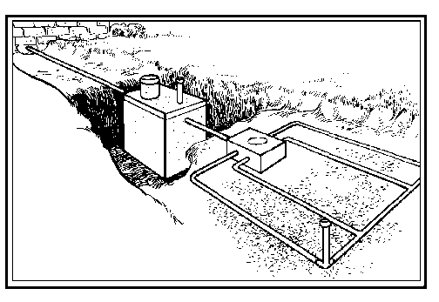

**ON-SITE WASTEWATER TREATMENT, HOW WE GOT HERE (Part 2)**

Between 1997 and 2007 numerous studies and reports have looked at the sanitary management options in the planning area. These include Facilities Plan and Sewer Service areas identification for the adjacent communities, as well as the Linn Sanitary District. All these studies identified existing wastewater management in areas that either included the District’s residents or in areas adjacent to the District.

**Sanitary Waste Management Needs**.

The initial step in the facilities planning process was to define the district boundaries and to evaluate whether there was a need to do anything beyond existing management. This involved identifying existing conditions, assessing future conditions, evaluating alternatives, financial considerations and selecting the best alternative.

To evaluate current conditions, data, and information about existing sanitary waste management within the District was collected from numerous sources:

-Time of Sale Inspection Reports

-County Sanitarian Records

-Sanitary Needs Questionnaire

-Random Inspections

-Opinion of the Walworth County Sanitarian

Considerations in evaluating final wastewater management needs involved looking at the existing on-site systems for:

-Density of existing development

-Limitations on area available for replacement systems

-Steep slopes

-Conditions of existing on-site systems

-Soil type and evaluations.

Due to variable conditions and needs within the District, the District was divided into nine subsections for planning purposes. The facilities plan recommended the following by subsection:

Area 1, 2, 5, 6, 9 – Improvements and alternatives needed.

Area 3, 4, 7, 8 – Use of existing systems could continue.

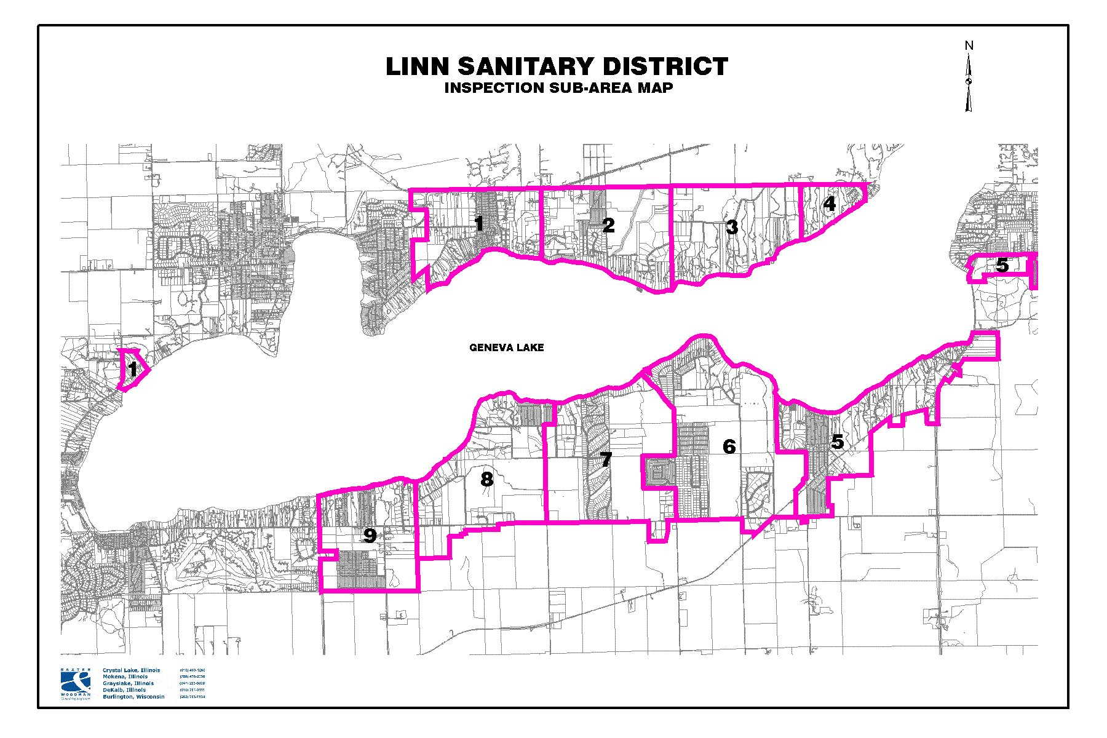

The above map shows the boundary of the Linn Sanitary District as defined by the dark line. The numbered subsection designates sub-areas of the sanitary district used in our facilities planning and management implementation strategies.

It was doubtful whether building a new wastewater treatment plant for the needed areas was going to get State approval. The State felt that there are already several existing, near-by plants that could be used. Attempts to buy access to existing collection and treatment systems were unsuccessful unless those areas were annexed into the specific community.

As an addendum to the original facilities plan in 2007, the District attempted to work with the Town of Geneva on the north shore for access into the Walworth County Metropolitan Sewerage District’s (WALCOMET) system. This was unsuccessful for several reasons more to the idea not being popular in the Town of Geneva than access to WALCOMET. Going alone without the Town of Geneva was extremely costly and not popular with the District’s residents that would be served.

Attempts to construct the Districts own collection and delivery system for the south shore area, to the Walworth - Fontana Pollution Control Plant offered us a possibility of getting there but not in the door.

In addition to preparing a detailed wastewater facilities plan the District wanted to know what its residents preferred for future wastewater management. During the summer of 2000 the District implemented a public awareness and hearing process to solicit public opinion regarding alternatives. This involved attending numerous Homeowners Association meetings, public information meetings, four newsletters specifically addressing the various options and a mailed-out survey to 1,940 owners of land, with a 61% response of improved parcels. Seventy-eight per cent of the respondents favored staying with on-site systems with repair, replacement and up-grade as needed. With most of the District residents being part-time residents, this made sense from a cost perspective. A second survey conducted in 2016 again found a majority of resident surveyed still preferred staying with on-site systems (**Type 1**).

Responding to the recommendation of the facilities plan and its residents wishes, the District made the commitment to the **Type 1** alternative with the known caveat of a District-wide POWTS inspection program. During the summers of 2001-2005 over 1,320 POWTS within the District were inspected by professional, Wisconsin licensed inspectors. This survey found:

403 systems---Functioning, all is good.

495 systems---minor repairs but functioning.

156 systems--- some component not functioning properly.

278 systems--- unknown, some components could not be found.

The District worked with many of the property owners and Walworth County Sanitation Department to upgrade those system that needed work. Many of the “problem” systems have been upgraded or repaired. As of 2023 we are still following up with inspection on a few systems that have not shown any upgrading, <15 properties.

Once a system has been upgraded to County approval, they are placed on a State mandated, County administered, 3-year pumping/inspection program (blaze orange card program). The District feels comfortable in saying that over 90% of the systems within the District are participating in the pumping/inspection program. As the initial facilities plan approaches 20 years old, the District is considering revisiting and updating portions of the original wastewater facilities plan.

NEXT: Groundwater, drinking water and private wells.