The Linn Sanitary District has committed to decentralized water supplies and on-site wastewater treatment for its residents.

*Linn Sanitary District’s Sanitary waste management and groundwater protection*

In previous newsletters the District discussed the efforts and information that went into the District’s choice of on-site or decentralized sanitary waste management. Education is a key element in a successful decentralized sanitary waste management approach. Owners must understand their responsibilities in assuring an operating POWTS. They must embrace and implement those responsibilities in a timely manner.

With the help of a three-year pumping program (the “orange card “program), the District feels that most of the POWTS within the District are pumped and viewed every three years. This program is state mandated, and County administered. This pumping information can be viewed on the County’s web site at: <http://gisinfo.co.walworth.wi.us/LURMSanitInsp/> . You will need the tax ID number of the parcel you wish to search for.

Private drinking water wells are not required to be tested. It is up to the homeowner to assure that their well is working correctly, and their water is potable. Contact Walworth County at 262-241-3200 for more well testing information.

**TEST YOUR WELL ANNUALY!**

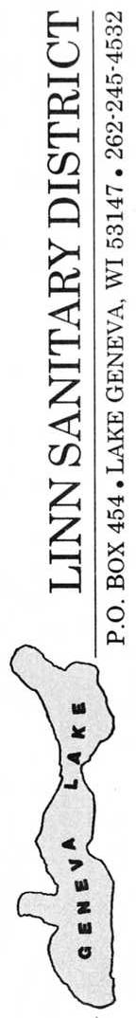

**LINN SANITARY DISTRICT**

P.O. Box 949

Lake Geneva, WI 53147

262-275-6300 ex.53

https://townoflinn.com/sanitary-district/

NEWSLETTER

Winter 2023-2024

-About Your Private On-Site Wastewater Treatment Systems -

-Dos and Don’ts with your POWTS -

-Making Your POWTS last longer-

-Common POWTS terms-

*-FOR OUR HEALTH-*

*-AND GENEVA LAKE’S PROTECTION-*

C:\Users\Ted\Documents\geneva lake\UW X figures\misc\WFP016.TIF 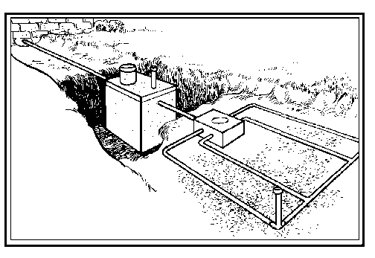

**What’s in a Private On-Site Wastewater Treatment System (POWTS)**

A POWTS is a specifically engineer small scale treatment plant that is designed for the site and the intended use. It protects your investment in your house. It would be difficult to live In your house without one.

A POWTS is comprised of two basic components, a septic tank and soil absorption area (SAS). The tank is designed to allow solids to settle within tank. When the tank becomes about one-third full of solids it should be pumped. The liquid and scum rise to the surface within the tank and is discharged to the SAS.

The SAS is where the wastewater enters the soil and is treated by the biological, chemical, and physical properties of the soil. before it enters the groundwater. As sites become more limited, more sophisticated SAS have been developed such as alternating treatment beds, mounds, pumping chambers, and activated treatment components, all to help in the final wastewater treatment. The size and type of the SAS is dependent upon the soils and the loading volume.

Within the septic tank there can be several components that help in the treatment process. They help keep the solids in the tank and prevents them from escaping to the SAS where they can plug the soil and cause system failure.

**KEEP OUT OF YOUR TOILET AND DRAINS**

**(Source: Wisconsin Liquid Waste Carriers)**

-Cat Litter -Treated Towelettes

-Egg Shells -Q-Tips

-cooking grease/oils -Cigarette Butts

-Sanitary products -Facial Tissue

-Disposable diapers -Dental Floss

-Cleaning chemical -Paints

-Medicines -Prescriptions

**Common POWTS Terms**

**Septic tank –** an underground watertight chamber made of concrete, fiberglass, or plastic, where solids settle, and wastewater flows in route to the SAS.

**Soil Absorption System (SAS).** Where wastewater soaks into the ground and is treated by the soil. SAS are in various sizes and shapes including mounds, trenches, and beds.

**Manhole –** The covered access into the septic tank**.**

**Riser –** Concrete rings used to raise the tank’s access hole closer to the ground surface.

**Inlet/Outlet pipes** – The inlet pipe enters the tank from the house. The outlet pipe leaves the tank and runs to the SAS.

**Baffles** – Devices in the septic tank located near the inlet and outlet pipes to reduce resuspension of sediment and prevents scum and sludge from leaving the lank and entering the SAS.

**Effluent filter**- A filter in the tank, located by the inlet/outlet pipes that prevent fine suspended material from moving into the SAS.

**Dousing chamber/tank** - The dousing chamber is where wastewater is pumped up gradient to the SAS.

**Distribution box** – allows wastewater to be evenly spread in the SAS.

**Clean-out ports** – located in the SAS to allow for pressure to be added to the SAS lines to backflush the pipes.

**Observation pipe –** A pipe in the top of the septic tank for observing inside the tank.

Feqfffeqefeqfq3effefefefef

**You are having POWTS problems if you have:**

-wet spots in your yard over the seepage area or the tank

-odors in the home

-toilets that are empty of water

-gurgling drains

-water around basement floor drains

-the wastewater lift pump alarm is ringing frequently

-poorly draining toilets or sinks, especially in lower areas of the house.

**If you experience any of these signs, for your health and safety contact your plumber immediately.**

Remember these POWTS saving tips.

* **Think at the sink!** What goes down the drain has a big impact on your system. Fats, grease, and solids can clog a system’s pipes and drain field.
* **Don’t Overload the Commode!** A toilet is not a trach can. Disposable diapers and wipes, feminine hygiene products, coffee grounds, cigarette buts, and cat litter can damage a septic system.
* **Don’t Strain Your Drain!** Use water efficiently and stagger use of water-based appliances. Too much water use at once can overload.
* **Shield Your Field!** Tree and shrub roots, cars and livestock can damage your SAS. Keep them off your SAS.
* **Keep it Clean!** Contamination can occur when a septic system leaks due to improper maintenance. Be sure your drinking water is safe to drink by testing it regularly.
* **Protect It and Inspects It!** Regular septic system maintenance can save homeowners thousands of dollars in repair and protect public health.

**(Source: USEPA)**