**IMPORTANT DATES IN THE HISTORY OF THE LINN SANITARY DISTRICT’S EFFORTS.**

1998-99 The Linn Sanitary District conducted its first on-site POWTS inspections.

2000 A Sanitary Waste Management Facilities Plan was prepared addressing several wastewater management options.

2001 A survey of district’s residents found a 3/1 preference to stay with decentralized on-site systems.

2001 The Facilities Plan was amended to include the residents’ preference and the chosen alternative of decentralized management.

2001-2004 The District conducted a district-wide POWTS inspection of over 1,300 systems

2005 The District continued discussion with neighboring communities for paid access to their collection and treatment system, to no avail.

2007 The District explored the option of working with the Town of Geneva for sewers in selected areas on the north shore, to no avail.

2010 Amended Faculties Plan for the Fontana/Walworth area of the District.

2011 59 wells were tested for bacteria, nitrate, arsenic and chloride.

2014 Working with GLEA, and the Walworth CO Public Health, the District coordinated the testing of over 400 wells for potability.

2016 A resurvey of residents confirmed preference for decentralized wastewater management.

2017 Working with the GLEA, the District initiated a five- year private well testing program on 13 selected wells.

2020-2024 The District reinspected 45 POWTS looking for upgrades on bad systems

Since inspections began, the District has been in discussion with

Walworth County Sanitation Dept. to upgrade failing systems.

**Keep a record of any work done on your POWTS.**

**Keep it with your important documents. Include:**

**-Date of Work**

**-Contractor or contact**

**-Description of Work**



LINN SANITARY DISTRICT

P.O. Box 454, Lake Geneva WI

262-275-6300 ext. 53

**LINN SANITARY DISTRICT**

P.O. Box 949

Lake Geneva, WI 53147

262-275-6300 ex.53

https://townoflinn.com/sanitary-district/

NEWSLETTER

Fall 2024

-The Effluent Filter-

-Important Dates in LSD’s Efforts-

-the Linn Sanitary District’s formation-

.

*-FOR OUR HEALTH-*

*-AND GENEVA LAKE’S PROTECTION-*

C:\Users\Ted\Documents\geneva lake\UW X figures\misc\WFP016.TIF 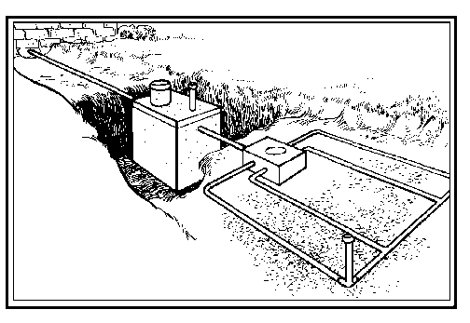

***The BIRTH of the***

***LINN sanitary district***

***THE EFFLUENT FILTER.***

In the past, when discussing POWTS, their maintenance and operation, we talked about two components, the septic tank and the drain field (Soil Absorption System). However, as our understanding of on-site wastewater management and technology advances, a new important component has entered the discussion, the Effluent Filter

The effluent filter, now required on new systems, is in the septic tank near the outlet. Most septic tanks can be retrofitted with some type of effluent filter. It is designed to be removed as needed for cleaning with access through a vent/opening in the tank. Homeowners can clean the filter by removing it and rinsing with a hose. Its maintenance and cleaning are often part of a service contract with installer or pumper.

It is designed to capture many of the floating synthetics and small floating particulates. These particles if allowed to leave the septic tank, will eventually plug the outlet pipe and the soil, causing significant system failure.

If you don’t have an effluent filter, talk to your plumber about installing one and establishing a cleaning schedule.

In reviewing some Linn Sanitary District files, several old documents from the District’s formation in 1946 were found.

A summary of the District’s formation follows below.

October 31, 1946 – A petition was filed by town residents with the Linn Town Clerk (Hugh Robinson) setting forth the reasons for forming a Sanitary District. The object of the district would be to address “garbage removal service and a supervision of water supplies and sewage disposal and to generally improve the sanitary condition within said district.”

October 15, 1946 - The Linn Town Board of Supervisors, Franklin Walsh, Bert Palmer and Chairman Libbey, ordered the Town Clerk to set a public hearing on the petition for November 15, 1946. The Town Clerk posted notice of the hearing at three public locations on November 2, 1946.

At the November 15, 1946, public hearing on the formation of Linn Sanitary District, the Town Clerk certified that the requirements as established by law had been met. This included proper noticing, posting, identified boundaries, needed signatures, and posted bond. Mr. Bakkom moved to recommend to the Town Board that the District be established. Second by E. Schmidt. Motion carried.

Chairman Libbey declared that the District is established, and it will be named the Linn Sanitary District. Its first commissioners for two years would be Harold Hartshorne Jr., Alexander Button and Hugh I. Robertson. The Board designated $50/month for the secretary and a sum of $4 a meeting for the commissioner.

The proposed district would be 2,900.25 ac in size. The statues required that owners of 60% of the land to be impacted must sign the petition. The acreage of land owned by the signers amounted to 37.4 acres more than the required amount.

Subsequent annexations by neighboring municipalities and by the District have changed the District’s size. Of significance was the November 15, 1946, annexation into the District of seven lakefront lots in the Town of Walworth.

Today the Linn Sanitary District includes all Linn Town lands on the north shore between the Village of Williams Bay and the City of Lake Geneva. On the south shore it extends from the Village of Fontana to The City of Lake Geneva. It extends to roughly south of South Shore Dr. and to Linton Rd. Today the District encompasses more 4,000 ac., has over 2,000 parcels and has historically represented 80% of the Town’s population. With a 2024 state equalized value of $3.4 billion, the District’s 2024 mil rate is 0.01869.