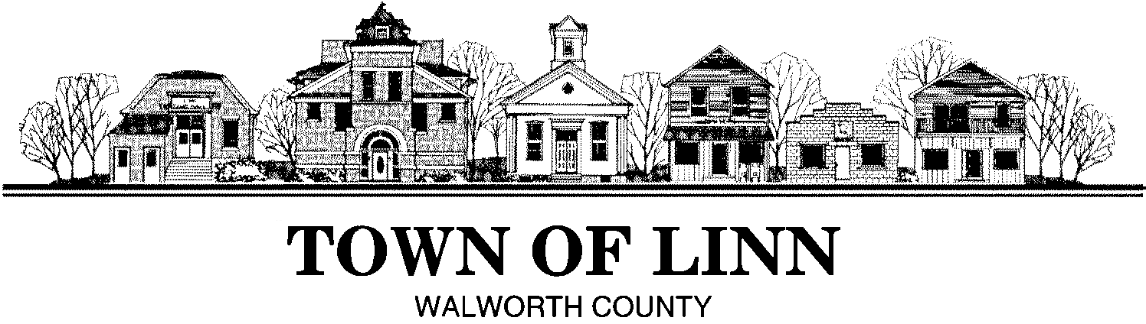

2025

**Notice to Bidders- Pavement Maintenance**

The Town of Linn will accept pavement maintenance bids until 12:00 pm on Friday, February 28, 2025. Bids must be received by the Town Clerk Alyson Morris, W3728 Franklin Walsh Street, P.O. box 130 Zenda, WI 53195. A performance Bond is required.

The Town Board has the right to accept or reject any and all bids and accept the bid most advantageous to the Town.

For further information and project specifications contact Matt Wittum, Highway Superintendent, Town of Linn at (262) 275-6300 ex. 17 or [linnhighway@townoflinn.wi.gov](mailto:linnhighway@townoflinn.wi.gov)